**Session 10**

**Assignment 1**

Write a program to implement WordCount using Pig.

The command lines used to implement the WordCount program using Pig.

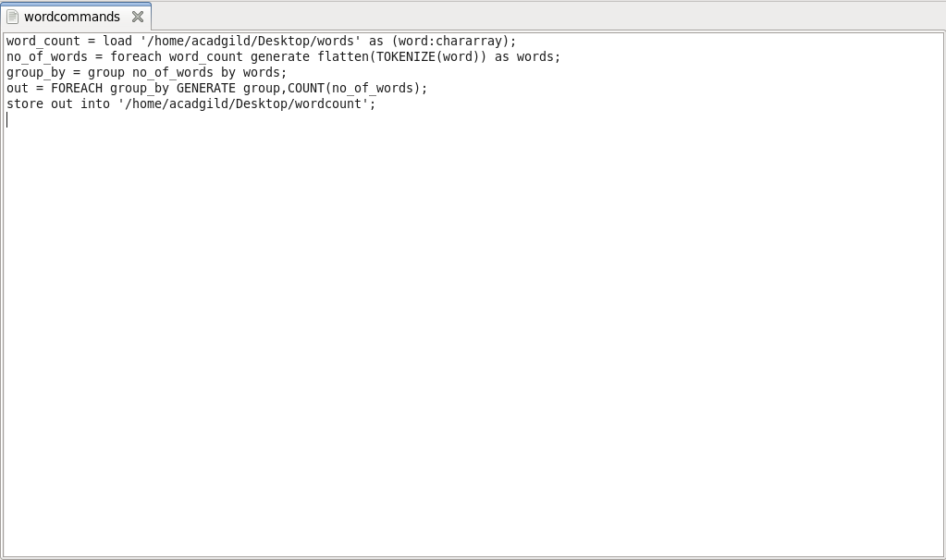

* The File for which the word count has to be performed is fed into the pig shell with the help of LOAD COMMAND.
* Flatten command - Convert bag in to tuples.
* Group by – to group similar words.
* Count command – to count the grouped word.
* Store command – to store the output as a text file.

These texts were used as file to use WordCount program by Pig.

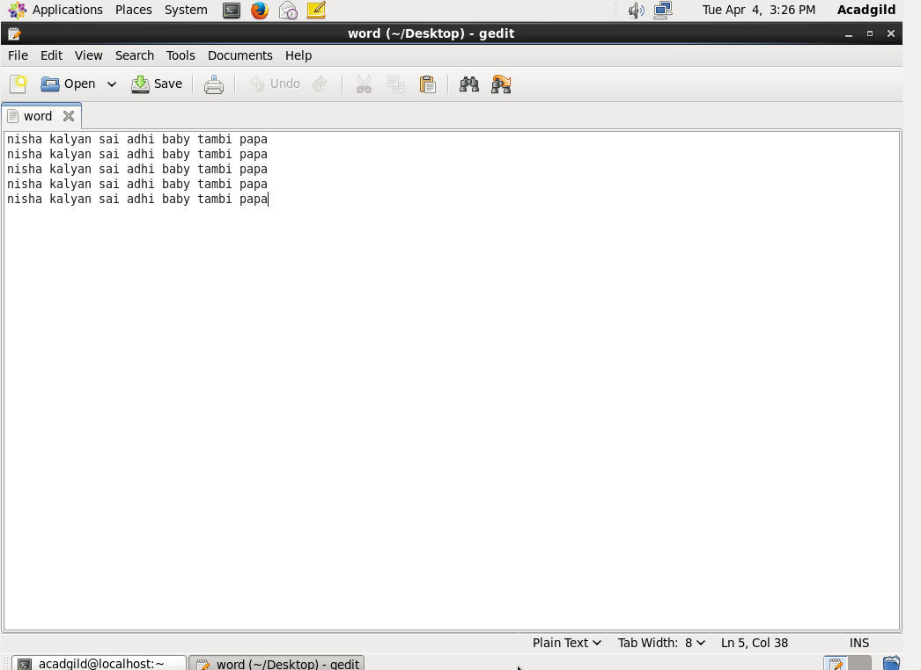

Command line to run the Word Count program by using Pig

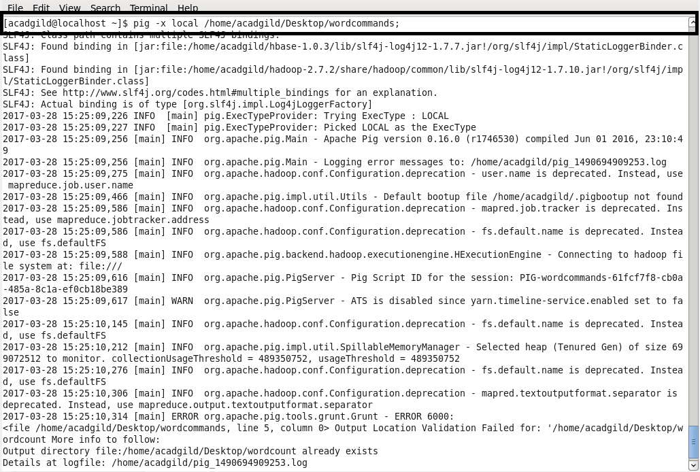

FOREACH:

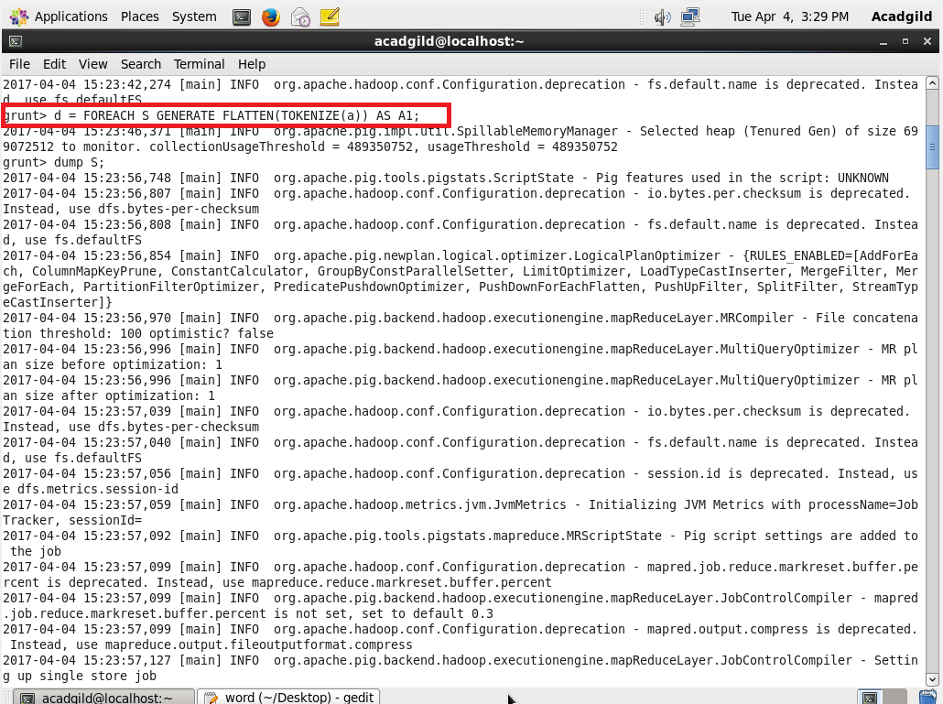

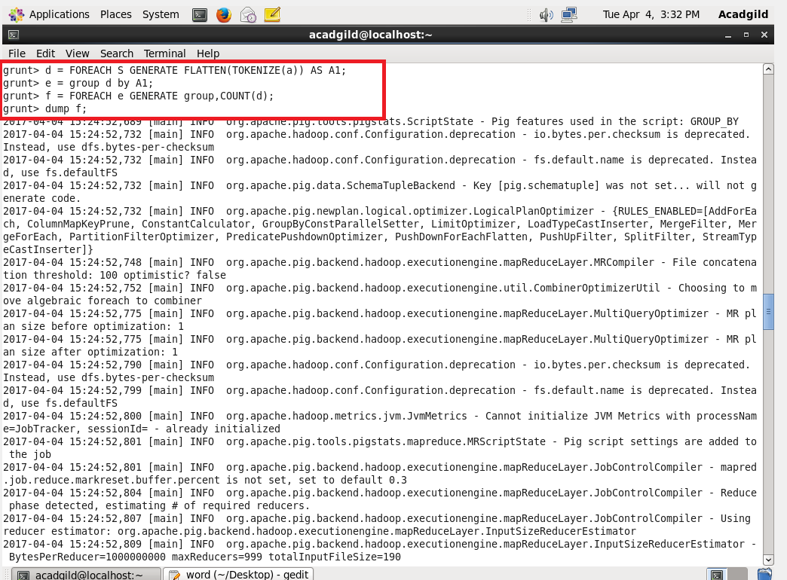

Output:

